Battery Selection

|  |  |
| --- | --- |
| Max current | quntity |
| 4000mA | 4 |
| 500mA | 1 |

max current   
  
4 x 4000 + 1 x 500 = 16500mA  
  
average current  
  
( 4000 + 500 ) / 2 = 2250mA  
  
battery voltage   
12v  
  
battery max current   
  
we will put factor of safety 1.1  
1.1 * 16500 = 18150mA  
  
capacity

Duration = Capacity [mAh] / average current [mA]  
capacity >= 0.5 * 2250 = 1125 mAh

|  |  |  |
| --- | --- | --- |
| Voltage | Max current | Average current |
| 12v | 18000mA | 2250mA |

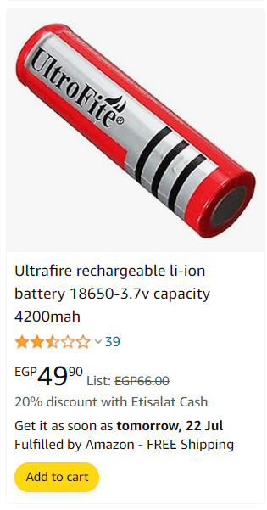

A pack of 4 series battery   
price : 196 pounds  
  
  
  
  
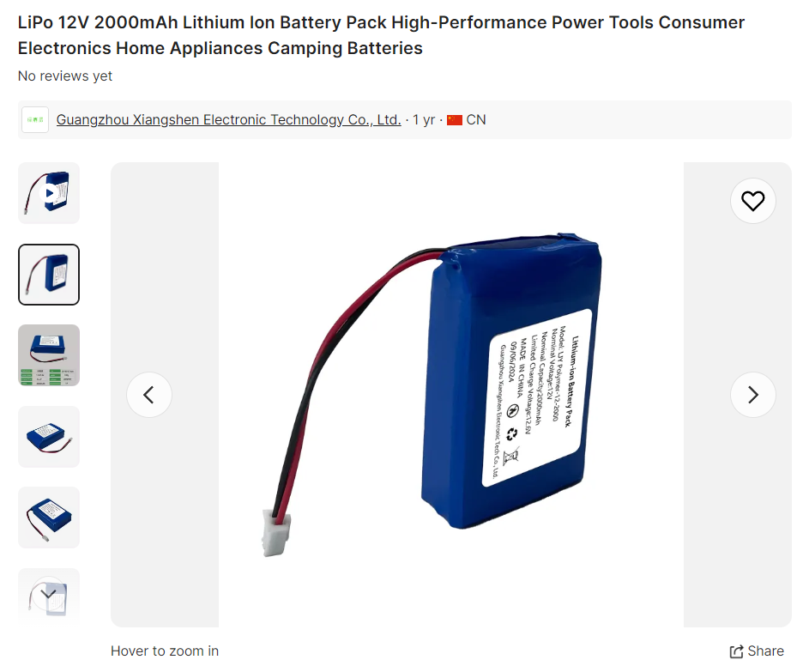

Price : 264 pounds